**INDIA GENERAL ELECTIONS RESULT ANALYSIS 2024**

**Total Seats**



**What is the total number of seats available for elections in each state?**

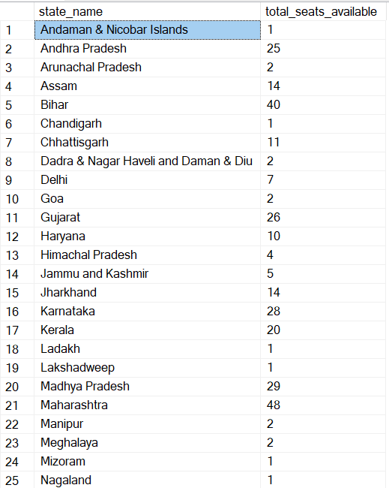 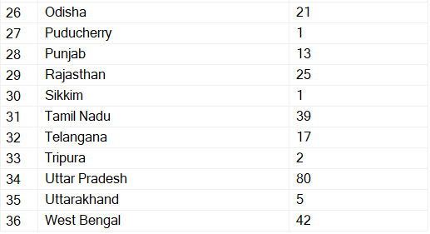

**Total Seats Won by NDA Allianz**



**Seats Won by NDA Allianz Parties**

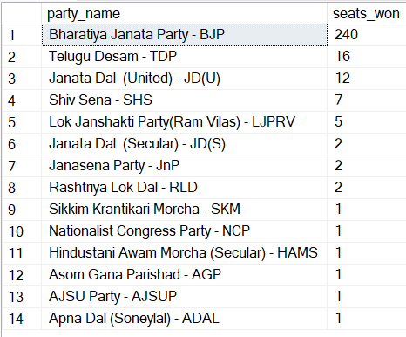

**Total Seats Won by I.N.D.I.A. Allianz**

**Seats Won by I.N.D.I.A. Allianz Parties**

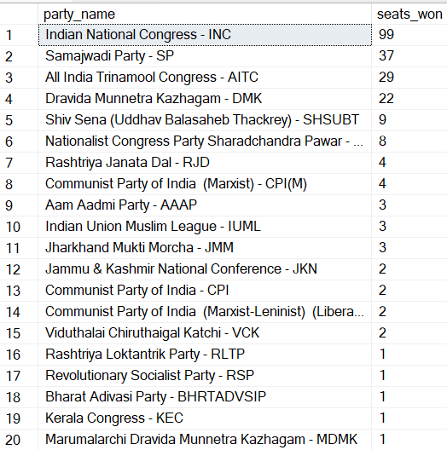

**Add new column field in table partywise_results to get the Party Alliance as NDA, I.N.D.I.A and OTHER**

**Which party alliance (NDA, I.N.D.I.A, or OTHER) won the most seats across all states?**

**Winning candidate's name, their party name, total votes, and the margin of victory for a specific state and constituency?**



**What is the distribution of EVM votes versus postal votes for candidates in a specific constituency?**

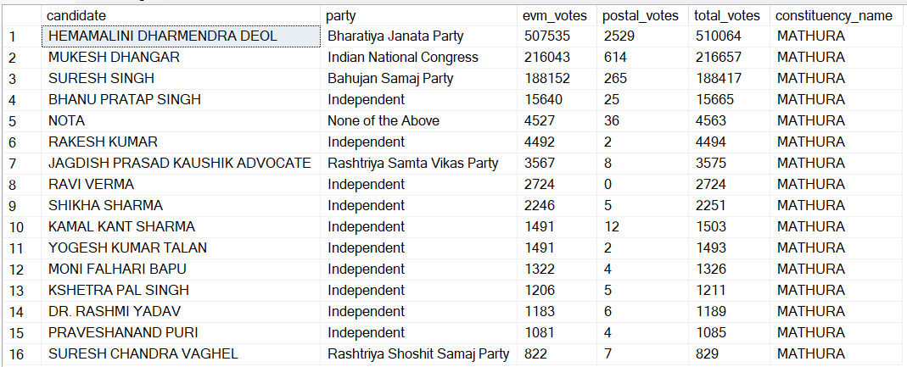

**Which parties won the most seats in s State, and how many seats did each party win?**

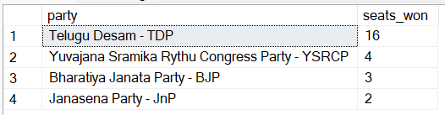

**What is the total number of seats won by each party alliance (NDA, I.N.D.I.A, and OTHER) in each state for the India Elections 2024**

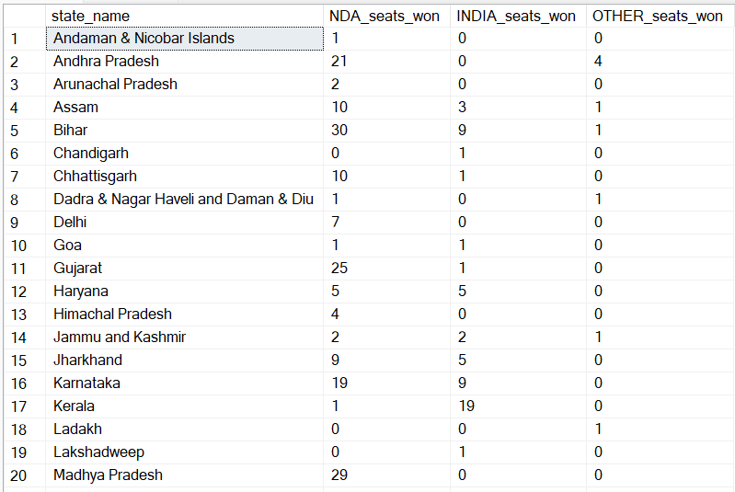

**Which candidate received the highest number of EVM votes in each constituency (Top 10)?**

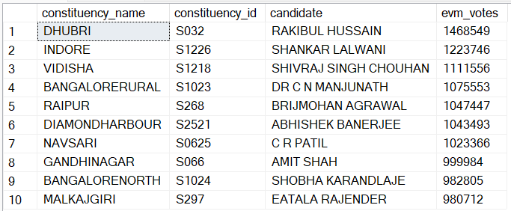

**Which candidate won and which candidate was the runner-up in each constituency of State for the 2024 elections?**

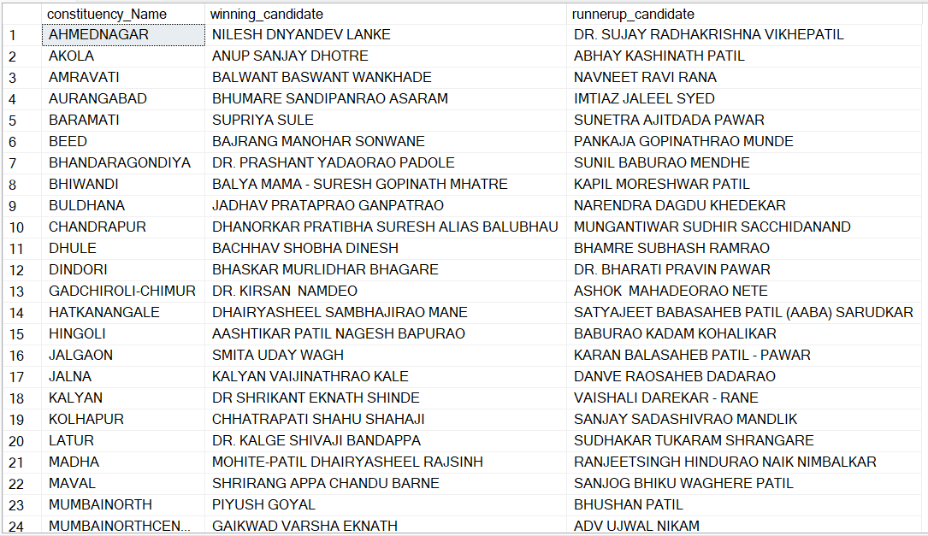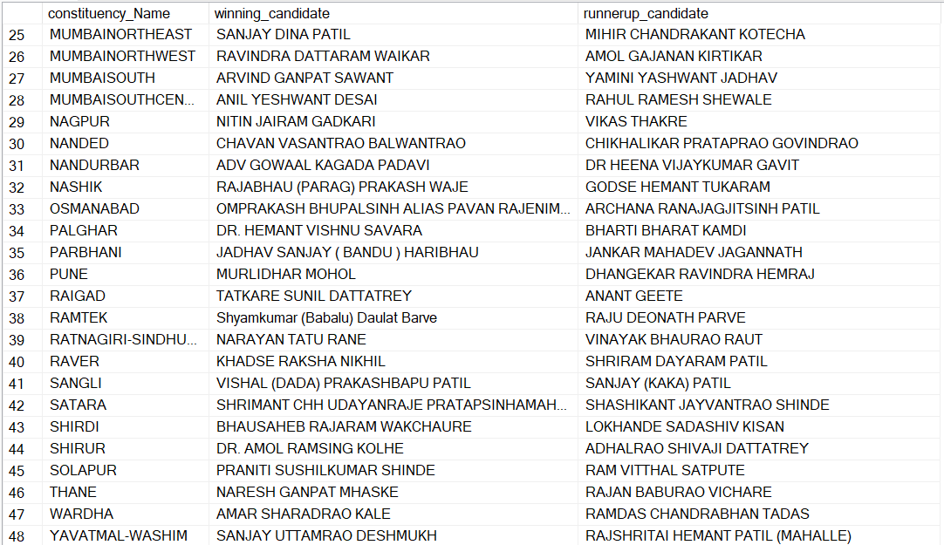

**For the state of Maharashtra, what are the total number of seats, total number of candidates, total number of parties, total votes (including EVM and postal), and the breakdown of EVM and postal votes?**

